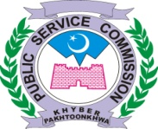

Khyber Pakhtunkhwa Public Service Commission

OFFICE ORDER
It is circulated for information of all concerned that all Interviews scheduled by the Khyber Pakhtunkhwa Public Service Commission stands postponed and the last date for the advertisement i.e. 02/2020 extended till further orders.

Deputy Director Admin
Dated: 11-04-2020

